GOOGLE ADS CAMPAIGN MANAGEMENT
PROJECT REPORT
Campaign Brand: Grace
Campaign Theme: Women's Farshi Suits — Everyday and Festive Fashion
Project Type: Digital Marketing Capstone Project
Campaign Platform: Google Ads
Target Market: India
Submitted by: Khushi Bansal
Internship/Programme: Digital Marketing

1. Introduction
For this project, I selected Google Ads campaign management as a practical digital marketing exercise. I created a campaign proposal for Grace, a fictional women's ethnic-wear brand in India that specialises in farshi suits for everyday wear and festive occasions.
The project focuses on planning a Google Ads campaign for the fictional brand Grace. It includes identifying the target audience, preparing advertising content, selecting a budget and bidding strategy, and reviewing the campaign setup.
During the practical exercise, Google Ads guided me towards a Performance Max campaign after I selected purchases as the campaign goal. I used the available setup options to understand how a campaign is created. The campaign is for learning and demonstration purposes only and has not been launched as a live paid campaign.

2. Brand Overview
Grace is a proposed online fashion brand offering women's farshi suits in everyday and festive styles. Its collection is planned for casual outings, family gatherings, festivals, and weddings.
The proposed product price range is ₹2,000–₹4,000, placing the brand in the mid-range ethnic-wear segment.
The imagined website would include an introduction to the brand, product collections, product descriptions, prices, size information, shipping and return details, and contact information.
Brand tagline: Grace — Everyday comfort, festive style.

3. Campaign Proposal

3.1 Campaign Objective
The main objective of this campaign is to bring more relevant visitors to the proposed Grace website through Google Search Ads. The campaign will focus on people who are already searching online for women's farshi suits.
As Grace is a fictional brand created for this project, the campaign will be planned as a practice exercise. The aim is to learn how to choose keywords, write suitable ads, set a budget, and understand how campaign performance can be measured.

3.2 Campaign Type
I have selected Google Search Ads because they can display text advertisements when people search for products related to the brand. For example, someone searching for “festive farshi suits” may be interested in exploring Grace's festive collection.
This format suits the project because the ads can be organised around two product categories: everyday farshi suits and festive farshi suits.

3.3 Target Audience
The proposed target audience is women aged 18–35 in India who are interested in ethnic wear and online fashion shopping.
The campaign will focus on people looking for farshi suits for casual outings, family gatherings, festivals, and weddings. The ads will use different messages for everyday and festive styles so that they are relevant to the customer's search.

3.4 Campaign Duration
The proposed campaign duration is 14 days. This period would allow the campaign to be monitored and reviewed if it were launched. Since this project is a simulation, no live campaign results will be collected.

3.5 Proposed Budget
The sample budget for this project is ₹3,500 for 14 days, based on a planned daily budget of ₹250.

The budget is divided between the two ad groups as follows:
Ad Group | Proposed Budget
Everyday Farshi Suits | ₹1,400
Festive Farshi Suits | ₹2,100
Total | ₹3,500
A larger share is allocated to festive styles to give that category more room in the proposed campaign budget. This is a planning decision for the exercise, not a result based on actual campaign performance.

3.6 Bidding Strategy
For this practice campaign, I plan to use the Maximize Clicks bidding strategy. Its purpose is to help generate website visits within the available budget.
If the campaign were launched, I would review the clicks, cost, and search terms to understand whether the ads were reaching relevant users.

4. Keyword Research and Strategy

4.1 Purpose of Keyword Research
Keyword research helps identify the words and phrases people may use when searching for a product online. For the Grace campaign, I selected keyword ideas related to everyday and festive farshi suits.
The aim is to make the ads relevant to what people are searching for and organise them into two groups based on their interests.

4.2 Selected Keywords
The following keywords are proposed for the campaign:
Everyday Farshi Suits | Festive Farshi Suits
everyday farshi suit | festive farshi suits
casual farshi suit | embroidered farshi suit
farshi suit for women | farshi suit for wedding
comfortable farshi suit | buy festive farshi suit online
buy farshi suit online | traditional farshi suit
These are initial keyword ideas for the project. If the campaign were launched, I would use Google's Keyword Planner and review actual search terms to refine the list.

4.3 Ad Group Structure
I have divided the campaign into two ad groups so that each group can have its own keywords and advertisement copy.
Ad Group 1: Everyday Farshi Suits
This group will focus on people searching for farshi suits for regular outings, casual occasions, and family gatherings. The ad message will highlight versatile styles suitable for everyday wear.
Ad Group 2: Festive Farshi Suits
This group will focus on people looking for farshi suits for festivals, weddings, and special occasions. The ad message will highlight festive designs and traditional styles.

4.4 Keyword Matching and Relevance
For a practical campaign setup, I would begin with phrase match and exact match keywords to keep searches more closely related to the products being advertised. I would also check the search terms report, if available, to identify irrelevant searches and add negative keywords where necessary.
For example, searches for free sewing patterns or suit stitching tutorials may not match the intention of someone shopping for ready-made farshi suits.

4.5 Why This Strategy Was Selected
I chose these keyword themes because they relate directly to the two collections planned for Grace. Separating everyday and festive searches also makes it easier to write relevant ads and compare the performance of each category if the campaign is launched.

5. Advertisement Creative and Copy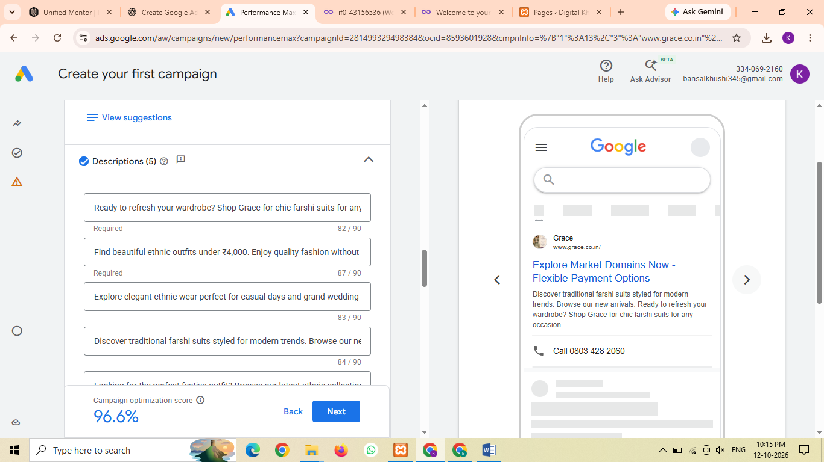
Figure 1: Sample advertisement creative prepared for the fictional Grace brand.
For this project, I prepared sample advertising content for Grace, a fictional women's ethnic-wear brand specialising in farshi suits. The advertisement focuses on everyday comfort, festive occasions, and traditional fashion with a modern look.
Brand tagline: Everyday comfort, festive style.
Sample advertisement headline:
Discover Elegant Farshi Suits by Grace
Sample advertisement description:
Explore farshi suits for everyday outings, family gatherings, festivals, and weddings. Discover elegant ethnic styles designed for different occasions.
Product price range: ₹2,000–₹4,000 (proposed).
Creative concept:
The sample creative features women's farshi suits in elegant colours, with a focus on embroidery, traditional details, and festive styling. The aim is to make the advertisement visually appealing to people interested in women's ethnic wear.
Purpose of the advertisement:
The creative demonstrates how a fashion brand could present its products through online advertising. Since Grace is a fictional brand, the copy and creative are examples prepared for this project and do not represent a live advertisement.

6. Google Ads Campaign Setup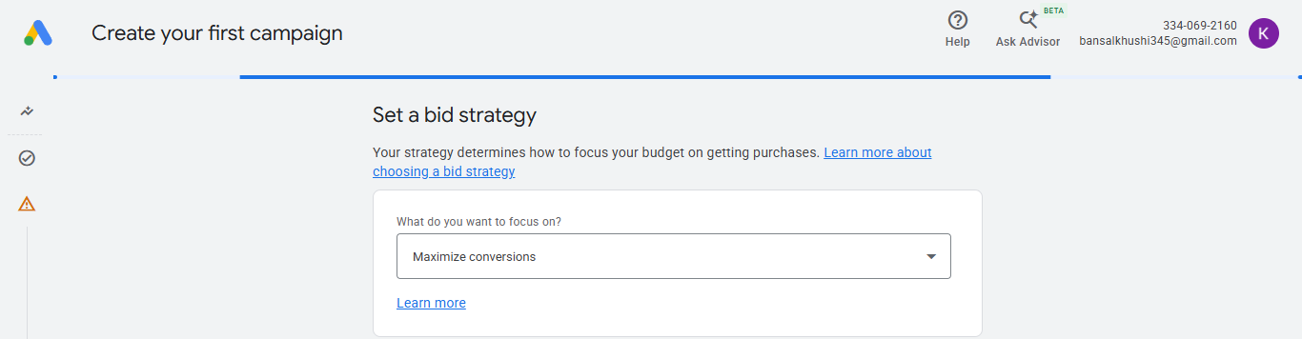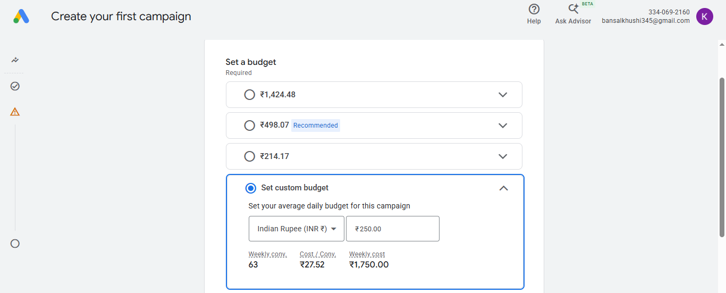
I explored the Google Ads campaign creation process to understand the settings involved in preparing an online advertising campaign. The campaign was created as a practice exercise for the fictional brand Grace.
Campaign goal: Purchases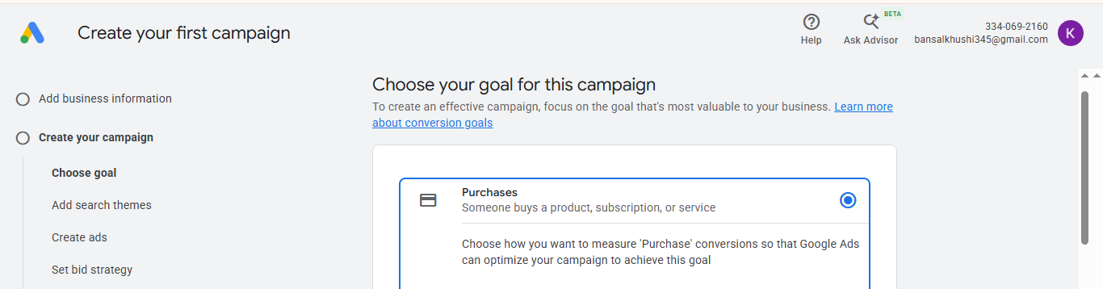
Campaign type: Performance Max (Because P-Max optimizes heavily for conversions or conversion value)
Target market: India
Target audience: Women aged 18–35 who may be interested in women's ethnic wear, farshi suits, festive outfits, and traditional fashion.
Proposed daily budget: ₹250
Proposed campaign duration: 14 days
Proposed total budget: ₹3,500
Bidding strategy: Maximize conversions, selected for the practice setup.

7. Campaign Evaluation and Expected Outcomes
The purpose of this campaign is to understand how Google Ads can be used to promote a women's ethnic-wear brand. The proposed campaign focuses on reaching people who may be interested in farshi suits for everyday wear and special occasions.
Expected outcomes
- Improve awareness of the fictional Grace brand among the intended audience.
- Attract relevant visitors to a suitable product landing page.
- Encourage interested customers to explore the farshi suit collection.
- Understand how campaign budgets, bidding strategies, audience settings, and advertising creatives work in Google Ads.
How campaign performance could be measured?
If the campaign were launched in the future, its performance could be evaluated using the following metrics:
- Impressions: The number of times an advertisement is shown.
- Clicks: The number of times people click on the advertisement.
- Click-through rate (CTR): The percentage of impressions that result in clicks.
- Conversions: Completed actions, such as purchases, when conversion tracking is properly configured.
- Cost per conversion: The advertising cost associated with each recorded conversion.
Since this project uses a practice setup and the campaign has not been launched, actual impressions, clicks, conversions, and advertising costs are not available.

8. Challenges and Learning
While working on this project, I explored the Google Ads campaign setup process and learned how different settings affect campaign planning.
One challenge was choosing an appropriate budget. Google Ads recommended a higher daily amount, but I kept the proposed budget at ₹250 per day for this practice project.
Preparing advertising content for a fictional brand was also useful because it required me to think about the target audience, product benefits, and the type of message that could attract potential customers.
Overall, this project helped me become more familiar with Google Ads, campaign budgeting, advertising copy, and the importance of checking website and conversion-tracking requirements before launching a real campaign.

9. Conclusion
This project gave me practical exposure to the process of planning a Google Ads campaign for a fictional women's ethnic-wear brand. I worked on the brand concept, target audience, keyword ideas, advertising copy, budget planning, and campaign settings.
During the setup process, I explored the Performance Max campaign type and the Maximize conversions bidding strategy. I also learned that selecting an appropriate budget is important and that a real campaign needs a suitable landing page and properly configured conversion tracking.
Although the campaign was not launched, the exercise helped me understand the basic steps involved in preparing an online advertising campaign. The experience will be useful as I continue learning about digital marketing and paid advertising.

